9.1 Measuring rate
Name: ____________________ Class: ____________________ Due date: 10.29
1 .The apparatus shown is used to measure the speed of a reaction.
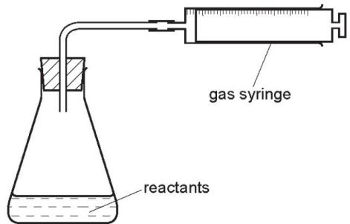
Which equation represents a reaction where the speed can be measured using this apparatus? （ ）
A $Mg(s)+2HCl(aq)→MgCl_{2}(aq)+H_{2}(g)$
B $HCl(aq)+NaOH(aq)→NaCl(aq)+H_{2}O(l)$
C $Fe(s)+CuSO_{4}(aq)→Cu(s)+FeSO_{4}(aq)$
D $2Na(s)+Br_{2}(l)→2NaBr(s)$

3. The rates of some chemical reactions can be measured by using the apparatus shown.
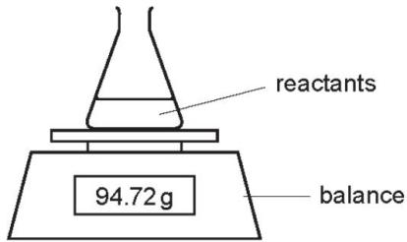
For which reaction is this apparatus suitable? （ ）
A $MgCO_{3}+2HCl→MgCl_{2}+CO_{2}+H_{2}O$
B $Mg+ZnCl_{2}→MgCl_{2}+Zn$
C $MgCl_{2}+2NaOH→Mg(OH)_{2}+2NaCl$
D $MgO+2HCl→MgCl_{2}+H_{2}O$

4. A student measures the rate of two reactions.
In one reaction, there is a change in mass of the reactants during the reaction.
In the second reaction, there is a change in temperature during the reaction.
Which piece of apparatus would be essential in both experiments? （ ）
A balance B clock C pipette D thermometer

5. A student was asked to measure the rate of reaction between dilute hydrochloric acid and marble chips at different temperatures.
Some of the apparatus used is shown.
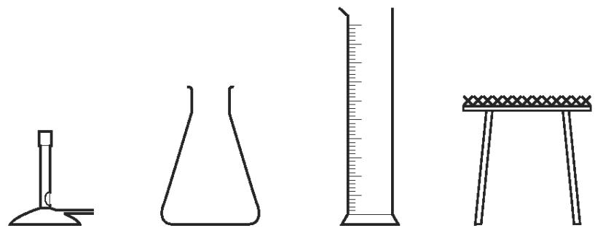
Which two other pieces of apparatus would be needed? （ ）
A balance and pipette
B balance and stopclock
C beaker and stopclock
D burette and pipette

6. A liquid X reacts with solid Y to form a gas.
Which two diagrams show suitable methods for investigating the rate (speed) of the reaction? （ ）
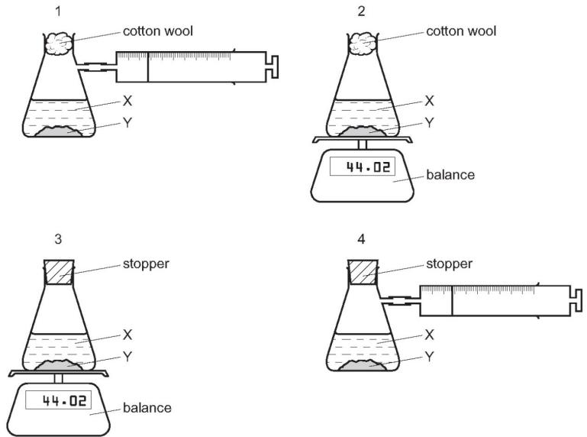
A 1 and 3 B 1 and 4 C 2 and 3 D 2 and 4

7. The mass of a beaker and its contents is plotted against time.
Which graph represents what happens when sodium carbonate reacts with an excess of dilute hydrochloric acid in an open beaker? （ ）
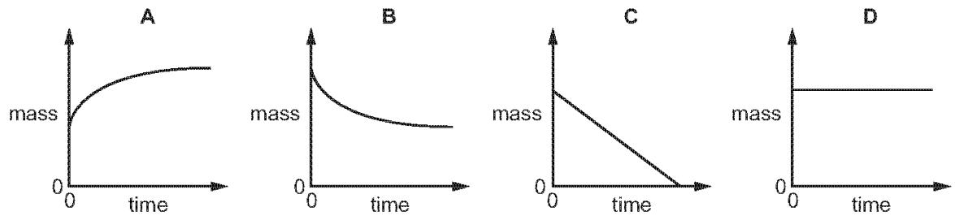
8. $20.0g$ of small lumps of calcium carbonate and $40cm^{3}$ of hydrochloric acid, concentration $2.0mol/dm^{3}$ were placed in a flask on a top pan balance.
The mass of the flask and contents was recorded every minute.
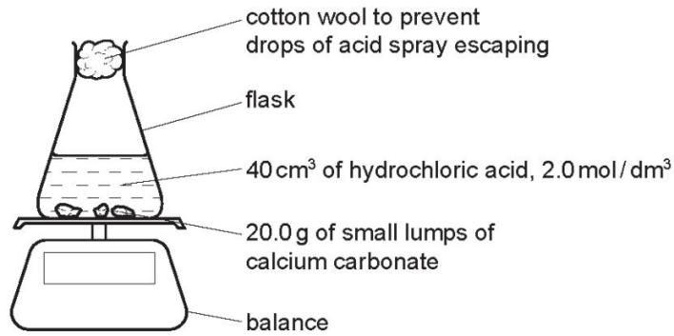
The mass of carbon dioxide given off was plotted against time.
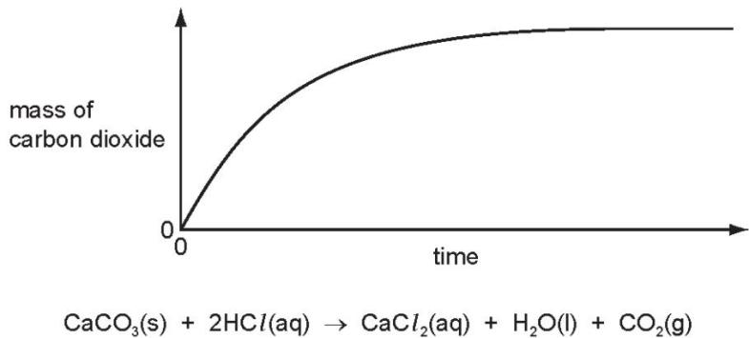
In all the experiments mentioned in this question, the calcium carbonate was in excess.
Explain how you could determine the mass of carbon dioxide given off in the first five minutes.
.......................................................................................................................................
...................................................................................................................................[1]
Label the graph F where the reaction rate is the fastest, S where it is slowing down and 0 where the rate is zero.
...............................................................................................................................................................................................................................................................[2]
Explain how the shape of the graph shows where the rate is fastest, where it is slowing down and where the rate is zero.
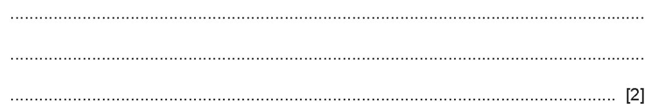

9. A student investigates the rate of reaction between lumps of calcium carbonate and dilute hydrochloric acid using the apparatus shown.
$$CaCO_{3}(s)+2HCl(aq)→CaCl_{2}(aq)+CO_{2}(g)+H_{2}O(l)$$
The calcium carbonate was in excess.
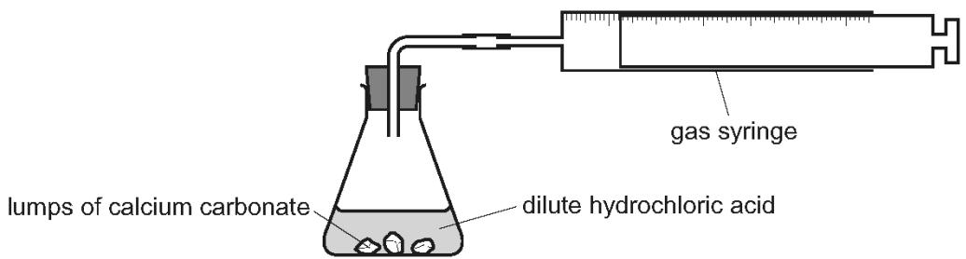
Which measurements should the student make during the reaction to determine the rate of reaction?
What happens to the rate of reaction as the reaction proceeds? Explain your answer.
